

**_________________________**

Shared Work Space Solution Proposal

Presented on: _______________

Presented by: Abdel Mahmoud

*Thank you for your time and interest in Work Space. I am pleased to summarize the options we have available to suit your needs in this proposal. At Work Space we understand that businesses grow so do their needs, that’s why once you join one of our facilities you can:*

* *Increase and expand your Work Space at any time*
* *Decrease and minimize your Work Space if your business is seasonal*
* *Move in-between our facilities as many times as you like*
* *Grow your business at your own pace*

*Further more, your monthly payment includes:*

* *Secure 24/7 access to your designated Work Space*
* *All your utilities and energy costs*
* *Your general liability insurance*
* *Your property maintenance fees and taxes*
* *Membership to all our facilities*

*I hope this proposal meets your business needs.*

*I will give you a call within the next 48 hours to see if you have any questions, however in the meantime please feel free to contact me directly if you need further assistance.*

*I look forward to welcoming you to one of our Shared Work Space facilities.*



***Abdel Mahmoud***

*Property Development Manager*

✆ 416.639.1543 ext. 101

🖂 abdel.m@sharedworkspace.ca

*Dear __________________,*

*Membership has its advantages, and comes standard with every office.*

Our Work Space Membership is the foundation of all our Work Space plans. It grants you complete access to our digital member network, events, and services, you also benefit from all the different amenities our different facilities offer. Once you become a member in one of our facilities you become a member in all of our facilities.

Your membership is included.

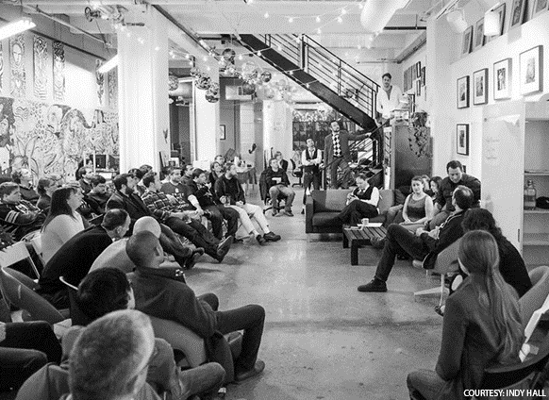



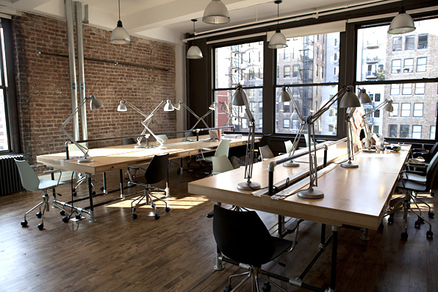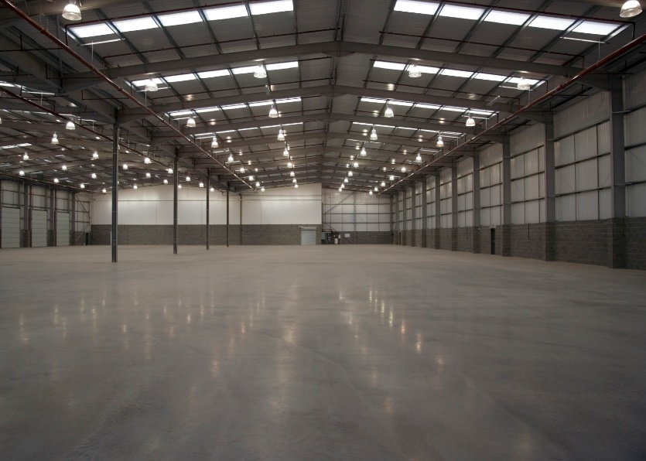

*Having the right Work Space is crucial for your business success.*

*The spaces we occupy shape who we are and how we behave. This has serious consequences for our psychological well-being and creative performance. Given that many of us spend years working in the same room, or even at the same desk, it makes sense to organize and optimize that space in the most beneficial ways possible.*

Your Work Space – What’s included.

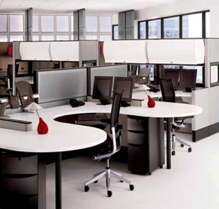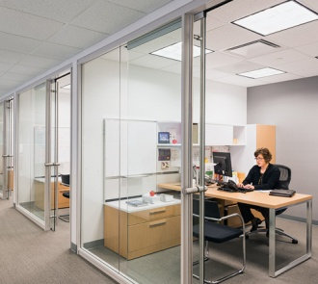

**YOUR FURNITURE**

*Your office is equipped with modern, functional and ergonomic office furniture – Designed to inspire and deliver a comfortable working experience.*

**YOUR PRIVATE OFFICE**

*Tremendous privacy and a lot of concentration come along with our private offices – a place for creativity, critical thinking, and BUSINESS!*

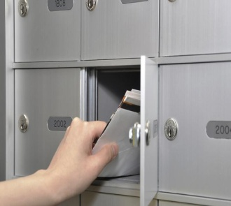

**MAIL BOX**

*Your own mailbox will be assigned according to your office number; all mail is organized and distributed to you.*

**FRONT DESK AND RECEPTION HELP**

*Your Facility Services Coordinator is on top of things so you can focus on what’s important, your business.*

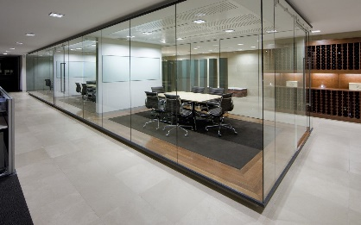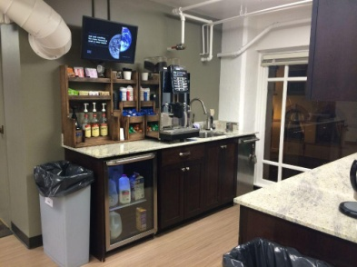

**OFFICE PHONE**

*Your office will be equipped with a dedicated telephone. Your facility service coordinator will be transferring all your incoming calls to your office’s phone so you can handle your business smoothly.*

**COFFEE AND TEA REFRESHMENTS**

*Ooh the most important part of the work day, the coffee – always hot and ready to go.*

**HIGH SPEED INTERNET ACCESS**

*High speed Fiber-Optic internet is supplied throughout the whole facility, allowing you to browse the internet freely.*

**MEETING AND TRAINNING ROOMS**

*Need a meeting space or two? no problem! your facility comes with a technology ready meeting space, from large LED TV's to touch sensitive white boards with open integration software.*

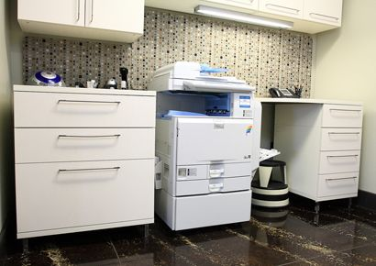

**PRINTER**

*Multifunction printers; you can print, copy, scan, and fax your documents.*

**ACCESS TO OPEN COLLABORATION SPACE**

*An opportunity to work outside your office, where you can socialize and network with your Shared Work Space family.*

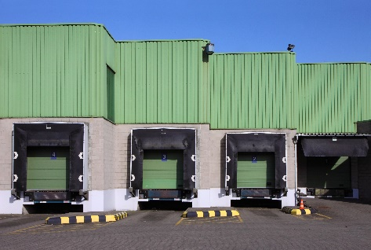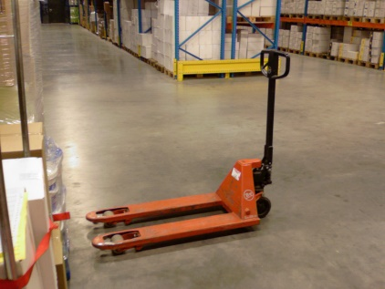

*\*The mentioned services above may vary from one facility to another, we will make sure to inform you with what your chosen facility includes.*

**MULTIPLE DOCK OPTIONS**

*Access to dock and drive in doors to accommodate every truck size.*

**PUMP TRUCKS AND DOLLIES**

*A wide range of manual and electric pump trucks and dollies to help you get the job done.*

**FULL CLEANING SERVICES**

*A professional cleaning team takes care of the cleanliness and tidiness of your space on daily basis.*

**PARTNERS COOPERATION**

*Take advantage of benefits and deals offered by Shared Work Space Inc. partners.*

Benefit from a fully flexible short term plan or SAVE with a long term agreement.

Rent space for

3 months, 6 months or 12 months

|  |  |  |  |  |  |  |  |
| --- | --- | --- | --- | --- | --- | --- | --- |
| Facility | Description | Office Size (sqft) | Office code | 3-month Term  Rent/Month | 6-month Term  Rent/Month | 12-month Term  Rent/Month | Notes |
|  |  |  |  |  |  |  |  |
|  |  |  |  |  |  |  |  |
|  |  |  |  |  |  |  |  |
|  |  |  |  |  |  |  |  |

Proposal prepared by Abdel Mahmoud, Proposal valid for 24hrs from date issued and is subject to availability, Prices exclude local tax and any additional services.

Base rent includes, 24/7 Access to facility and office proposed, High Speed internet access, Reception service (according to facility), Coffee and tea refreshments, meeting and training rooms and mail box service

Mississauga, Ontario Locations:

**Telford Facility** - 7050 Telford Way Unit #8 (Dixie and Derry Rd.)

**Matheson Facility** - 115 Matheson Blvd. West (Hurontario and Matheson Blvd.)

**General Facility** - 5266 General Rd (Dixie and Matheson Blvd.)

**Atlantic Facility** - 6141 Atlantic Dr. (Dixie and Britannia Rd.)

* Prices exclude local tax and additional services.

**ADDITIONAL SERVICES:**

* Internet Access and phone: $100.00 /month / user
* Coffee and refreshments: $30.00 / month / user
* Reception Services: $100.00 / month
* Office cleaning $40.00 / month / user
* Color laser printing: $10.00 / month / user for 100 prints/month
* Meeting Room Access: $45.00 /hr
* Additional office: $99.99 / day

**ALL INCLUSIVE INCLUDES:**

* Membership fee - Unlimited meeting and training room access
* Mail box service - Office cleaning
* Reception service - Phone service
* Color printing - Furniture
* Internet access
* Coffee and refreshments

Your proposal.

What’s next?

Contact Abdel Mahmoud at 416.639.1543 ext. 101 or email: [abdel.m@sharedworkspace.ca](mailto:abdel.m@sharedworkspace.ca)

To sign up we require the following items:

* A copy of your articles of incorporation or master business license in the case that your business is registered.
* A copy of a valid Canada issued photo ID (driver’s license).
* A VOID cheque for rent collection.
* First and last month rent plus 1-month security deposit paid via; interact, Visa, Master Card or certified cheque.

